TASK 1 – Identify the rooms in the office plan. (<https://ieltstrainingonline.com/ielts-listening-recent-actual-test-with-answers-practice-test-01/> listen to the second half of audio “SECTION 2” to solve the task).

1. Local Tours (D)
2. Interstate Tours (F)
3. International Tours (B)
4. Asian Region (E)
5. General Office (A)

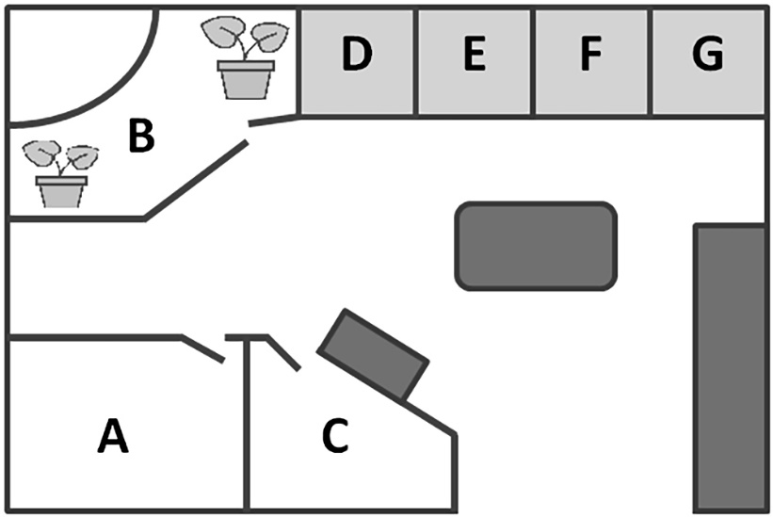

TASK 2 - Complete the labels (25-30) by writing **ONE WORD OR A NUMBER** for each answer. (<https://ieltstrainingonline.com/ielts-listening-recent-actual-test-with-answers-practice-test-01/> listen to the second half of audio “SECTION 3” to solve the task)

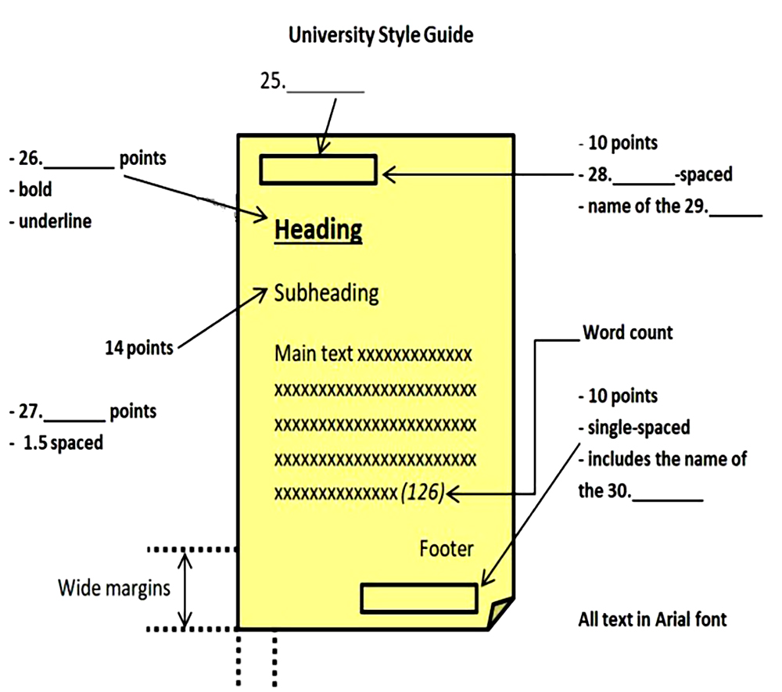

25.Header

26.16

27.12

28.single

29.work

30.teacher

TASK 3 - Complete the flowchart by writing **ONE WORD** for each answer. (<https://ieltstrainingonline.com/ielts-listening-recent-actual-test-with-answers-practice-test-02/> listen to the first half of audio “SECTION 3” to solve the task)

**Foundation for Essay Writing**

Decide on **1. _____** you like.

↓

Focus on **2. _____** area of interest.

↓

Write **3. _____** statement.

↓

Create **4. _____**

↓

Ensure this **5. _____** clearly.

TASK 4 – Label the floor plan. (<https://ieltstrainingonline.com/ielts-listening-recent-actual-test-with-answers-practice-test-04/> listen to the first half of audio “SECTION 2” to solve the task)

**1.**   Quiet reading (A)

**2.**   Computers (E)

**3.**   Newspapers & magazines (D)

**4.**   Reference books (F)

**5.**   Audio section ( C )

**6.**   Main library (B)

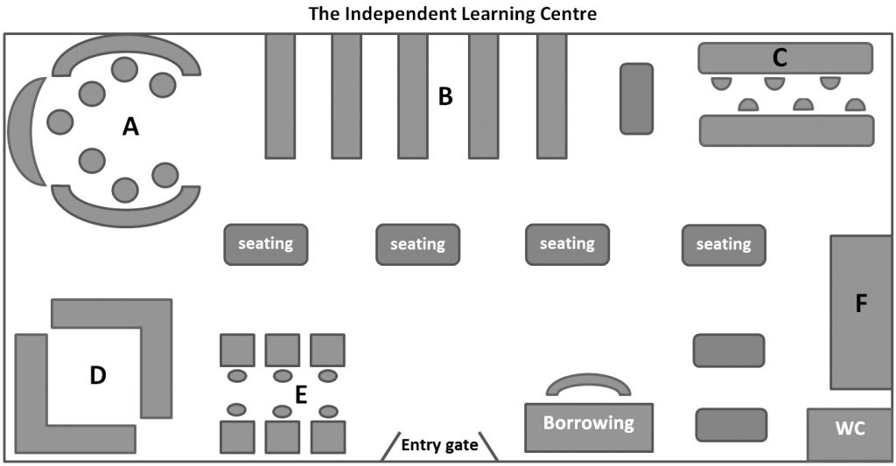

TASK 5 - Complete the diagram (36-40). Write **NO MORE THAN TWO WORDS AND/OR NUMBERS** for each answer. (<https://ieltstrainingonline.com/ielts-listening-recent-actual-test-with-answers-practice-test-04/> listen to the second half of audio “SECTION 4” to solve the task)

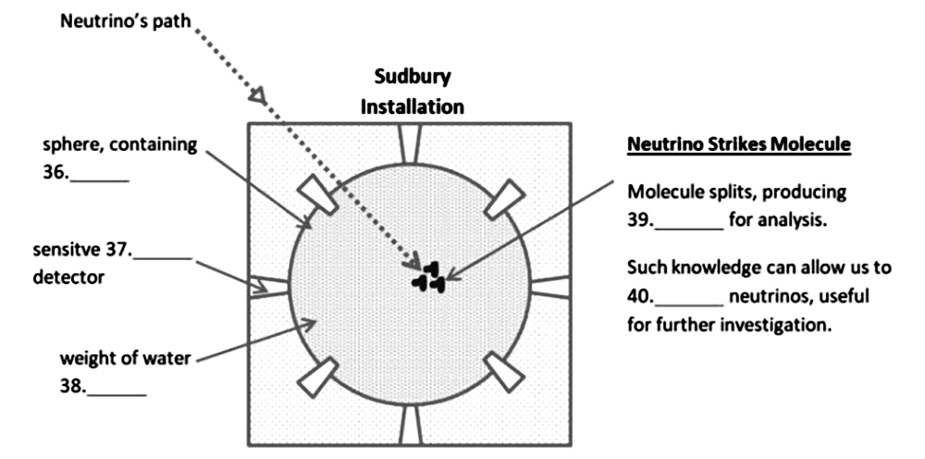

36.heavy water

37 electronic

38 1000 tons

39 electric current

40 control